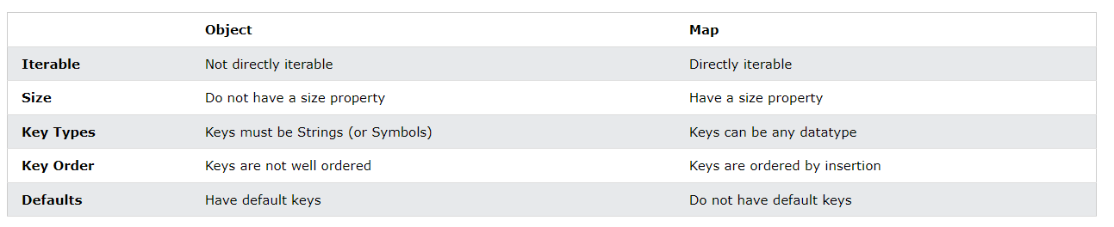

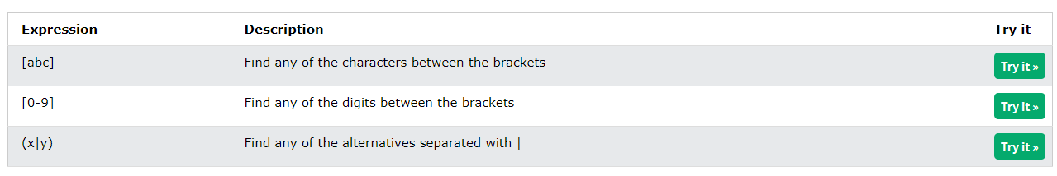

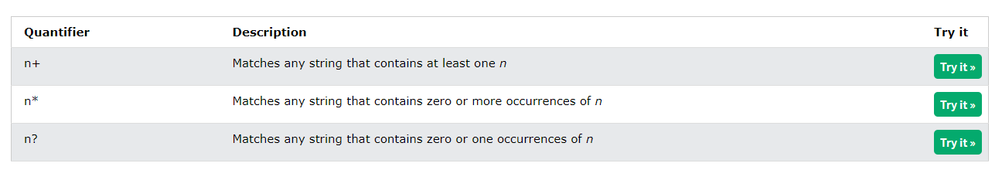

The lifetime of a JavaScript variable starts when it is declared.

Function (local) variables are deleted when the function is completed.

In a web browser, global variables are deleted when you close the browser window (or tab).